**Practical-1**

**AIM: Create database and collection.**

**1. Display all collection.**

**MONGODB query:**  show collections

**Output:**

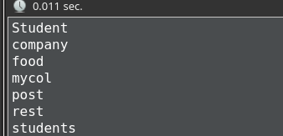

**2. Remove one of the collections from the database.**

**MONGODB Query:** db.Student.drop()

**Output:**



**Practical -2**